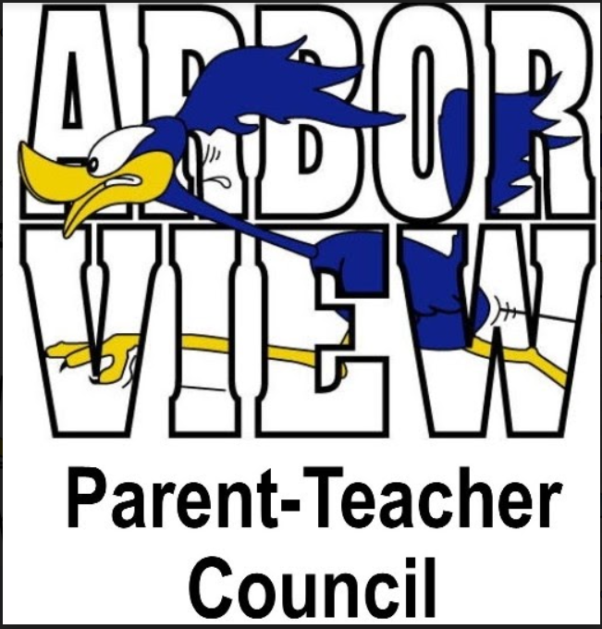

Agenda
January 11, 2022

- Call to Order – 7:03pm
- Approval of Minutes – November minutes approved 7:03pm
- President’s Report – Stephanie Furlong
  - Last monthly district meeting with D89 PTC presidents was in November
  - Subs are still needed in the district, and pay has been increased. Please reach out to Mrs. Burnett
  - Calendar survey showed that families do not like half days; D89 submitted waiver to state of IL to reduce number of half days from 7 to 3 in the 2022-23 school year
  - Finance committee was formed from D89 parents and other community members. Looking at finance needs throughout the district, including logistical items such as parking, lighting, etc.
  - Snow days this year will be eLearning this year
  - Arbor View parent (Yanick xxx) was selected to fill vacant spot on D89 board
- Treasurer’s Report – Stacy Moskos
  - Winterfest brought in $1,366 in profit for PTC
  - Amazon Smile also brought in funds lately
  - We had 2 bank accounts; closed 1 bank account and consolidated into the other. Currently have ~$14K in usable funds, so things are looking good!
- Principal’s Report – Mrs. Burnett
  - Holiday parties were a success; teachers and students were all really happy – Thank you!
  - MAP Testing results come home Wednesday, 1/12/22. These are mid-year reports, but were taken a little earlier than normal (December vs. January in previous years)
  - It’s been busy at Arbor View the last 2 weeks with Covid tracking, mitigation, etc
    - Students in classrooms are now 3 feet apart, and 6 feet apart in lunchroom
    - 2 custodians are working throughout the day/night/weekends to sanitize and clean
  - It is the goal across the district to keep schools open
  - We are short on subs, but staff is doing everything they can to keep teacher spots filled
  - There is a current pause on volunteers coming into AV (as well as all other schools in D89); this is just another layer of mitigation to keep students and staff safe
  - Valentine’s Day parties are TBD
    - If live parties can’t happen, can parent volunteers send (non-snack) treat bags, games, craft, etc? Yes – Mrs. Burnett to talk with teachers and district and will let us know
- Faculty Report – Mrs. Carlson & Ms. Clarey
  - Students loved the parties and the school/hallway decorations from the holidays!
  - Students have been great about masks, distancing, and indoor recess
- Committee Report
  - Fundraising- Brad Hemesath (Chicago Wolves, Boosterthon)
    - Chicago Wolves, Sunday, February 20th – Family day. More info to come soon
    - Boosterthon – deposit was made, and more info to come soon. Funds from this will cover future needs for the school (TBD based on feedback from teachers and staff)
  - Book Fair-Stephanie Furlong & Andrea Manderino
    - Book fair was successful! We had $5,889 in total sales, and $3,013 in profit for PTC
    - Spring book fair will be week of March 15th. Will likely be run the same way as it was in the fall
  - Restaurant Night- Talia Micek
    - Our restaurant nights haven’t been doing as well recently. Looking ahead to the coming months, we may do 3-4 per year, as opposed to once monthly. Made in Italy and Kimmers will be upcoming. More info and dates TBD

- Liaison Report
- Scouts – Girl Scouts - Olivia Loftsgaarden
  - The Girl Scouts participated in the Wheaton Light Parade and felt like celebrities! They are currently working on their ‘Making Games’ badge. They recently did a coding workshop with Dell, and are learning about drawing for their ‘Drawing Badge,’ with an art show coming up soon for their parents. They will also be doing pin swaps with Girl Scouts from all around the company. It’s cookie season! They are many favorites available, as well as some new cookies. They are $5 per box, and money earned goes to fund troop activities. Contact any troop leader or Girl Scout at AV to order! Reach out to Lisa Loftsgaarden to order
- Boy Scouts - Lupe Santillanes
  - Scouts sold over $35,000 in popcorn, which was the biggest sale in our history. We will have the Pinewood Derby in late January, and AV students will help vote on the car designs. Scouts recently made holiday cards for nursing homes, and they have several upcoming service projects and other fun activities planned.

- Old Business
- Stone Soup- Holly Redfern
  - The AV community collected over 2000 items, packed 76 personal item bags, and volunteered to sort at the pantry. It was a success, and more info highlighting the results will be sent out soon.
- WinterFest- Stacie Nelson
  - This was a fun event and was well-run and fun for students and families.

- New Business
  - Valentine’s Party-Stephanie Furlong
    - Details TBD once we learn more from Mrs. Burnett (Party in a box??)
  - Bingo
    - Plan for Zoom Bingo in mid- to late-March
    - Provide simple instructions, as in past years, some families didn’t know how to play
    - Perhaps teachers can do a Bingo game/lesson in the week before
  - Script
    - Gift cards purchased, and a certain percentage is given back to the school
    - There were issues with the code in late 2021, so we’re going to put this on the back burner for now and revisit later. Will need new parent volunteer, as current volunteer has student moving on to middle school
  - Amazon Smile
    - Mrs. Burnett to reach out to Rita Anderson for username and password and share with Stacy Moskos

- Comments

- Adjournment – 7:36pm

